

**AP Calculus BC**

Q1 Interim Assessment

Test Booklet 3

Free Response Questions

January 2017

School: _____________________________________________

Student Name: _____________________________________________

Teacher: _____________________________________________

Period: _____________________________________________

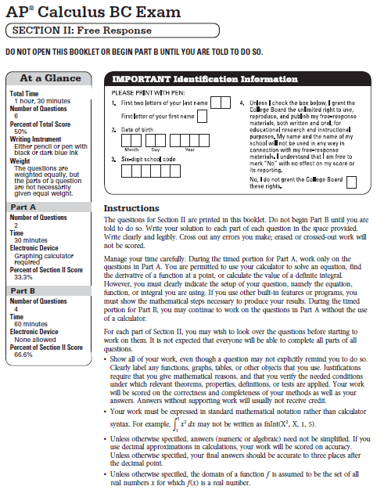

**CALCULUS BC**

**SECTION II, Part A**

**Time – 30 minutes**

**Number of problem – 2**

**A GRAPHING CALCULATOR IS REQUIRED FOR THESE PROBLEMS**

|  |  |  |  |  |
| --- | --- | --- | --- | --- |
| $$t$$ (days) | $$0$$ | $$10$$ | $$22$$ | $$30$$ |
| $$W'(t)$$ (GL per day) | $$0.6$$ | $$0.7$$ | $$1.0$$ | $$0.5$$ |

1. The twice-differentiable function $W$ models the volume of water in a reservoir at time $t$, where $W(t)$ is measured in gigaliters (GL) and is measured in days. The table above gives values of $W'(t)$ sampled at various times during the interval $0≤t≤30$ days. At time $t=30$, the reservoir contains 125 gigaliters of water.
2. Estimate $W''(5)$. Indicate units of measure.
3. Use the tangent line approximation to $W$ at time $t=30$ to predict the volume of the water, $W(t)$, in gigaliters, in the reservoir at time $t=32$. Show the computations that lead to your answer.

|  |  |  |  |  |
| --- | --- | --- | --- | --- |
| $$t$$ (days) | $$0$$ | $$10$$ | $$22$$ | $$30$$ |
| $$W'(t)$$ (GL per day) | $$0.6$$ | $$0.7$$ | $$1.0$$ | $$0.5$$ |

1. The twice-differentiable function $W$ models the volume of water in a reservoir at time $t$, where $W(t)$ is measured in gigaliters (GL) and is measured in days. The table above gives values of $W'(t)$ sampled at various times during the interval $0≤t≤30$ days. At time $t=30$, the reservoir contains 125 gigaliters of water.
2. Use a trapezoidal sum, with the three subintervals indicated by the data in the table, to

approximate $\int_{0}^{30}{W'(t)}dt$. Use this approximation to estimate the volume of the water $W(t)$, in gigaliters, in the reservoir at time $t=0$. Show the computations that lead to your answer.

1. The equation $A=0.3W^{2/3}$ gives the relationship between the area $A$, in square kilometers, of the surface of the reservoir, and the volume of water $W(t)$, in gigaliters, in the reservoir. Find the instantaneous rate of change of $A$, in square kilometers per day, with respect to $t$ when $t=30$ days.

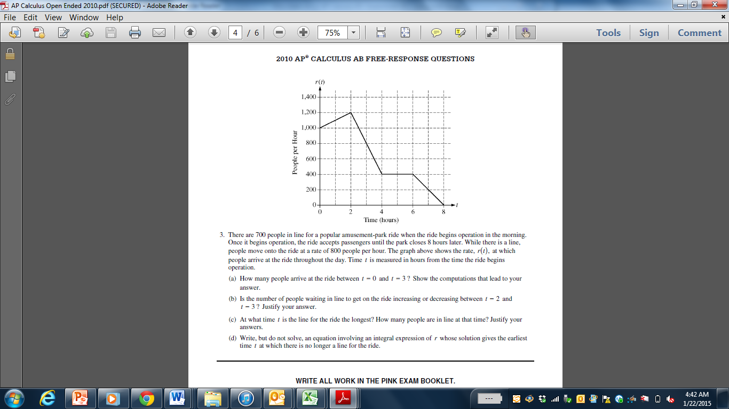

1. There are $700$ people in line for a popular amusement park ride when the ride begins operation in the morning. Once it begins operation, the ride accepts passengers until the park closes $8$ hours later. While there is a line, people onto the ride at a rate of $800$ people per hour. The graph above shows the rate, $r(t)$, at which people arrive at the ride throughout the day. Time $t$ is measured in hours from the time the ride begins operation.
2. How many people arrive at the ride between $t=0$ and $t=3$? Show the computations that lead to your answer.
3. Is the number of people waiting in line to get on the ride increasing or decreasing between $t=2$ and $t=3$? Justify your answer.
4. At what time $t$ is the line for the ride the longest? How many people are in line at that time? Justify your answers.
5. Write, but do not solve, an equation involving an integral expression of $r$ whose solution gives the earliest time $t$ at which there is no longer a line for the ride.

**END OF PART A**

**IF YOU FINISH BEFORE TIME IS CALLED,**

**YOU MAY CHECK YOUR WORK ON PART A ONLY.**

**DO NOT GO ON TO PART B UNTIL YOU ARE TOLD TO DO SO.**

**CALCULUS BC**

**SECTION II, Part B**

**Time – 60 minutes**

**Number of problems – 4**

**NO CALCULATOR FOR THESE PROBLEMS.**

**DO NOT BEGIN PART B UNTIL YOU ARE TOLD TO DO SO.**

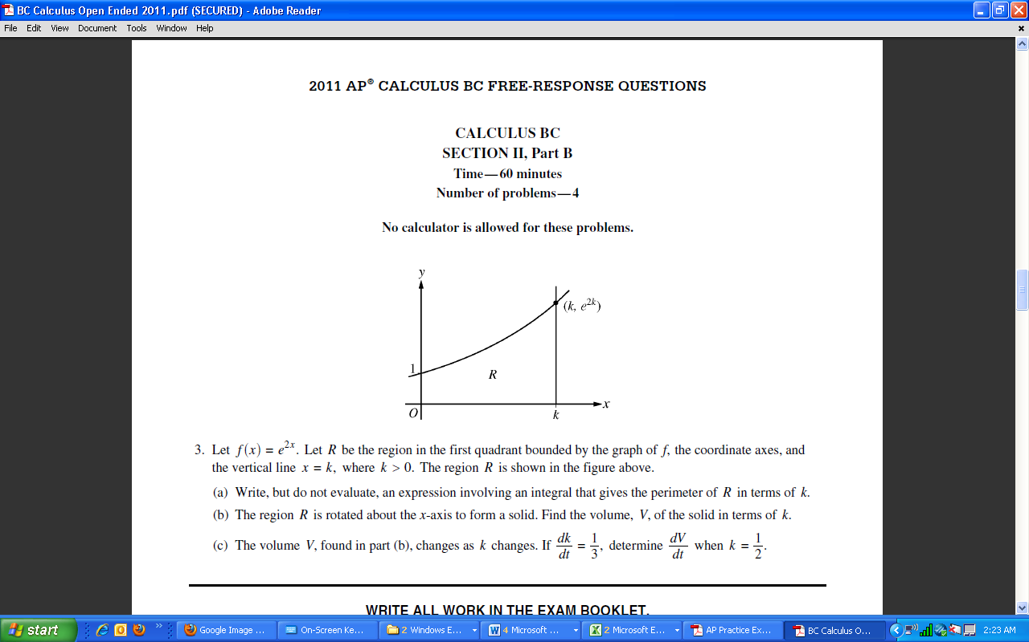

1. Let $f\left(x\right)=e^{2x}$. Let $R$ be the region in the first quadrant bounded by the graph of $f$, the coordinate axes, and the vertical line $x=k,$ where $k>0$. The region $R$ is shown in the figure above.
2. Find the area of region $R$ in terms of $k$.
3. The region $R$ is rotated about the $x$-axis to form a solid. Find the volume, $V$, of the solid in terms of $k$.
4. The volume $V$, found in part (b), changes as $k$ changes. If $\frac{dk}{dt}=\frac{1}{3}$, determine $\frac{dV}{dt}$ when $k=\frac{1}{2}$.
5. Consider the function $f$ given by $f\left(x\right)=xe^{-x^{2}}$ for all real numbers $x$.
6. Find the equation of the line tangent to $f$ at $x=1$.
7. On what interval(s), if any, is $f$ decreasing? Justify your answer.
8. At what of $x$ does $f(x)$ attain its absolute maximum? Justify your answer.
9. Find an antiderivative of $f$.

.

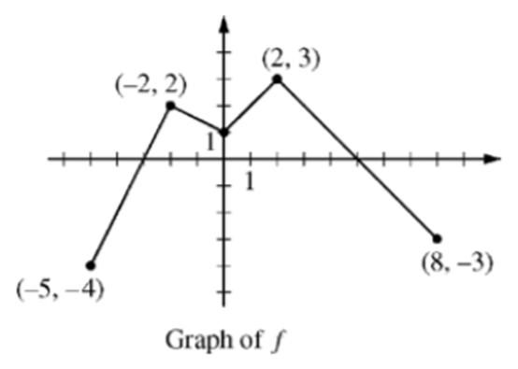

The continuous function $f$ is defined on the interval $-5≤x≤8$. The graph of $f$, which consists of four line segments, is shown in the figure above. Let $g$ be the function given by $g\left(x\right)=2x+\int_{-2}^{x}{f\left(t\right)dt}$.

1. Find $g\left(0\right)$ and $g(-5)$
2. Find $g'(x)$ in terms of $f\left(x\right).$ For each of $g''(4)$ and $g''(-2)$, find the value or state that it does not exist.
3. On what interals, if any, is the graph of $g$ concave down? Give a reason for your answer.
4. The function $h$ is given by $h\left(x\right)=g(x^{3}+1)$. Find $h'(1)$. Show the work that leads to your answer.
5. For $0≤t≤12$, a particle moves along the $x$-axis. The velocity of the particle at time $t$ is given by $v\left(t\right)=\cos\left(\frac{π}{6}t\right)$. The particle is at position $x=-2$ at time $t=0$.
6. For $0≤t≤12$, when is the particle moving the left?
7. Write, but do not evaluate, an integral expression that gives the total distance traveled by the particle from time $t=0$ to $t=6$.
8. Find the acceleration of the particle at time $t$. Is the speed of the particle increasing, decreasing, or neither at time $t=4$? Explain your reasoning.
9. Find the position of the particle at time $t=4.$

**STOP**

**END OF EXAM**